**1** **a)** Explain the term homeostasis. (2)

**b)** Name three conditions within the body that are controlled by homeostasis. (3)

**c)** Give one example of a control centre found in the body. (1)

**2** Changes in the environment are picked up by specialised cells. Messages are then passed along a pathway through the nervous system. The body is then able to respond to these environmental changes.

**a)** Match the different components with their function.

|  |  |
| --- | --- |
| Component | Function |
| Motor neurone | Transmits impulses to CNS |
| Effector | Co-ordinates the response |
| Sensory neurone | Carries the impulse around the CNS |
| Relay neurone | A muscle or gland that responds to stimulus |
| Central nervous system | Transmits impulse to an effector |

|  |  |
| --- | --- |
|  |  |
|  |  |
|  |  |
|  |  |
|  |  |
|  |  |

**b)** The terms below are part of the nervous pathway. Put the correct terms in to the spaces so that the nervous pathway is complete. Use only the initial letter provided. The first has been done for you.

|  |  |  |  |  |  |  |
| --- | --- | --- | --- | --- | --- | --- |
| C |  |  |  |  |  |  |

(3)

A. sensory neurone B. motor neurone C. stimulus D. relay neurone E. effector  
F. response G. receptor

**c)** The simplest of all responses to a stimulus is a reflex action.

**i)** Give one example of a reflex action. (1)

**ii)** Write down two characteristics of a reflex action. (2)

**3** The diagram shows a section through the eye.

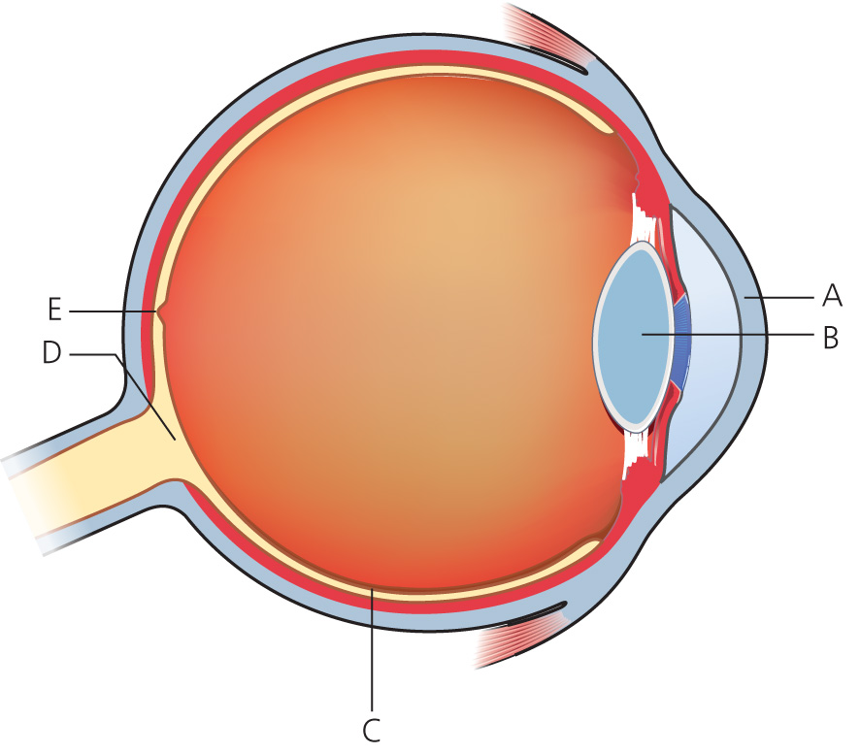

**a)** **i)** Label parts A to E on the diagram. (5)

**ii)** Where are the light sensitive cells found in the eye? (1)

**iii)** What are the two types of light sensitive cells called? (2)

**b)** The diagram shows how light from a near object and a distant object get focussed by the eye. The light rays and lens have been drawn in for the distant object.

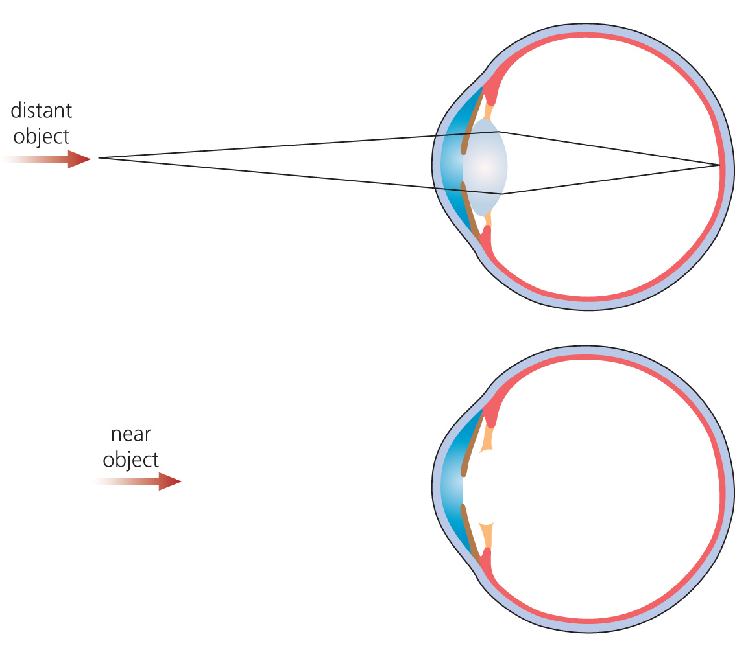

**i)** Draw in the lens and the light rays to show how the near object is focussed. (2)

**ii)** What is the role of A in focussing the near object? (2)

**iii)** How do the ciliary body and ciliary muscles help in focussing the near object? (3)

**iv)** What word describes the automatic focussing of light by the eye? (1)

**4** **a)** Which of the following groups of animals can control their body temperature?

A. Reptiles B. Fish C. Birds D. Invertebrates (1)

**b)** Where is the thermoregulatory centre of the body?

A. The brain B. The skin C. The sweat glands D. The pancreas (1)

**c)** Vasoconstriction is:

A. The widening of the capillaries in the skin.

B. The dilation of the skin capillaries.

C. The narrowing of skin capillaries.

D. The narrowing of the sweat duct. (1)

**d)** When an animal is cold they change their behaviour to help them warm up. Which of the following is NOT a behavioural response?

A. Reducing surface area by rolling up.

B. Huddling together with others.

C. Building a nest.

D. Shivering. (1)

**e)** When the body temperature falls below 35°C, a person will develop:

A. hypothermia B. hyperthermia C. hypothyroidism D. perithermia (1)

**5** The diagram shows the side view of the outside of the human brain.

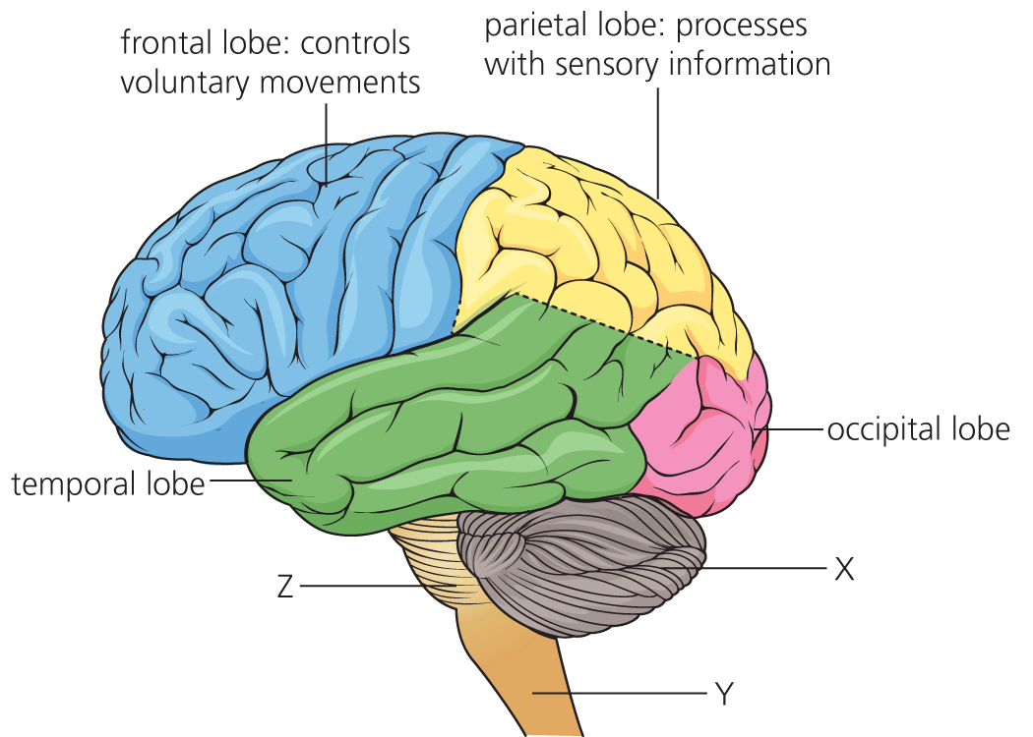

**a)** What is the role of the occipital lobe? (1)

**b)** Label structures X, Y and Z. (3)

**c)** Which of these labelled structures controls:

**i)** breathing and heart rate?

**ii)** posture and balance?

**iii)** is the route for many reflex actions? (3)

**d)** Fill in the gaps in the passage below on the brain and behaviour.

Changes in an animal’s behaviour result from changes in the ………..…… . A ………..… is a person who studies the brain.

Recent discoveries have shown that small changes in behaviour are due to changes in ……… .

The more synapses, the more complex the behaviour.

A synapse is a tiny ……… between two neurones. When a nerve impulse gets to the synapse, a chemical called a ……… diffuses across the gap.

This chemical triggers a new nerve impulse in the next neurone.

Neuroscientist   synapses   gap   neurotransmitter   brain (5)

TOTAL = 50

Answers

**1** **a)** the maintaining of a constant; internal environment (2)

**b)** body temperature; blood glucose levels; water levels (3)

**c)** brain; spinal cord; pancreas (1)

**2 a)**

|  |  |
| --- | --- |
| Component | Function |
| Motor neurone | Transmits impulse to an effector |
| Effector | A muscle or gland that responds to stimulus |
| Sensory neurone | Transmits impulses to CNS |
| Relay neurone | Carries the impulse around the CNS |
| Central nervous system | Co-ordinates the response |

(5)

**b)**

|  |  |  |  |  |  |  |
| --- | --- | --- | --- | --- | --- | --- |
| C | G | A | D | B | E | F |

(1/2 mark each correct answer rounded up = 3)

**c)** **i)** knee jerk when tendon is tapped; pupil constricting; (1)

**ii)** automatic; rapid; do not involve the brain; protective (2)

**3 a)** **i)** A = cornea; B = lens; C = retina; D = optic nerve; E = fovea (yellow spot) (5)

**ii)** in the retina (1)

**iii)** rods and cones (2)

**b)** **i)** One mark for shape of lens. One mark for lines correctly drawn. (2)

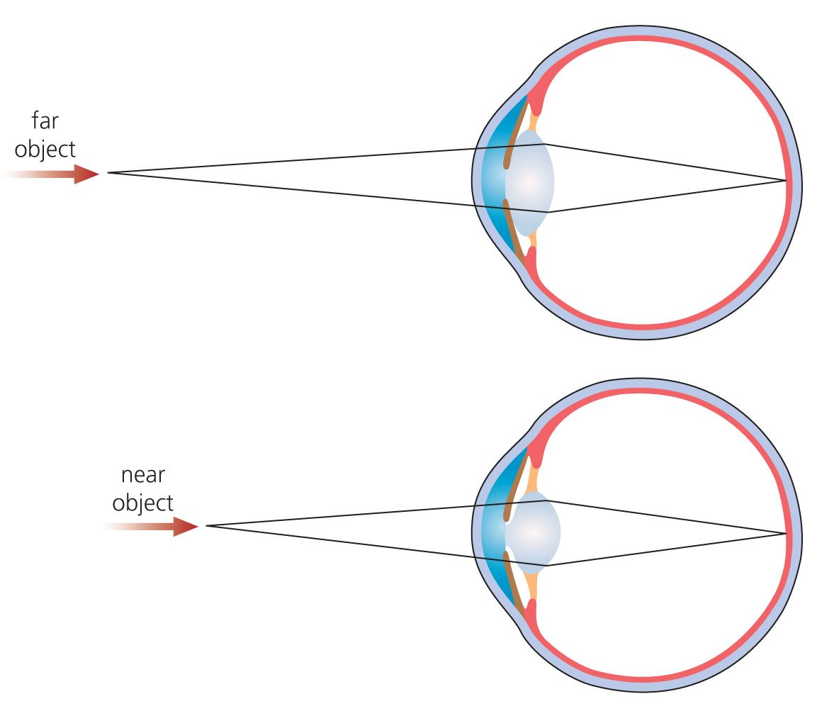

**ii)** A refracts or bends the light coming off the object.

Directs the light through the lens (2)

**iii)** Ciliary muscle is in the ciliary body. These hold the lens in place. These muscles contract and make lens shorter and fatter. Lens now able to bend (refract) the light more. (3)

**iv)** accommodation (1)

**4 a)** C

**b)** A

**c)** C

**d)** D

**e)** A (5)

**5 a)** processes visual information (from the eyes) (1)

**b)** X = cerebellum; Y = spinal cord; Z = medulla oblongata (3)

**c)** **i)** Z or medulla;

**ii)** X or cerebellum;

**iii)** Y or spinal cord (3)

**d)** Changes in an animal’s behaviour result from changes in the **brain**. A **neuroscientist** is a person who studies the brain. Recent discoveries have shown that small changes in behaviour are due to changes in **synapses**. The more synapses, the more complex the behaviour. A synapse is a tiny **gap** between two neurones. When a nerve impulse gets to the synapse, a chemical called a **neurotransmitter** diffuses across the gap. This chemical triggers a new nerve impulse in the next neurone. (5)

TOTAL = 50